**DELIVERABLE 1**

**Qualitative and Quantitative Analysis**

Based on the quantitative analysis of the sales data and qualitative analysis of customer complaints and social media comments, it's evident that there is indeed a problem at Northwind Trading. The February 2024 sales statistics show a consistent performance, but the March 2024 sales data indicates a downward trend in the number of transactions, total sales value, average daily sales value and Average Transaction Value.

**Figures**

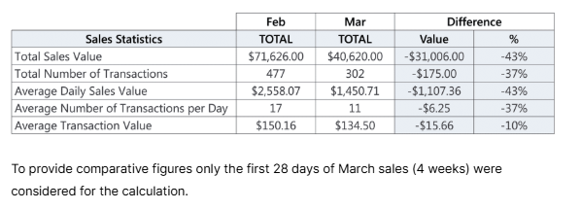

**Analysis**

March 2024 shows a 43% decrease in total sales value and 37% decrease in the number of sales transactions compared to February 2024. However, fluctuations within March indicate that there may be other factors contributing to the decline, rather than a consistent downward trend.

The March sales data shows a decline in both transactions and total sales value, despite a consistently high website traffic. It suggests that there is a problem affecting customer engagement and conversion rates, once they visit the website.

Further analysis of customer behaviour, website performance, and external factors is necessary to identify the root cause of the decline in sales.

The customer complaints and social media comments provide qualitative evidence of user dissatisfaction and frustration with the website's functionality and design.

The most common complaints are related to:

* Confusing and slow checkout process. Lack of guest checkout, customers required to register before completing their purchase.
* Limited payment options, only accepting credit cards.
* Poor online store design, including inconsistent product grouping and poor product descriptions, leading to confusion and frustration.
* Technical issues such as slow loading times.

To prevent a further decline of sales it is paramount to improve the checkout process, add additional payment options e.g. PayPal, Apple Pay, Google Pay, improve product grouping, tagging and descriptions and resolve the issues with the page loading speed.